Name: Rija Munawar Ali

ID: 68452

Program: BSSE

Course: Information Security(Lab)

Lab: Rainbow Tables & Brute-Force Attack (Practical)
Important — Ethics & Safety
Perform these exercises ONLY on lab VMs or test files/accounts you own. Do NOT use these techniques against real systems, services, or third-party accounts. This lab is for education and defense: to understand why salts, slow hashing, and strong passwords matter.

Learning Outcomes (CLOs)
CLO-1 (Understand) — Describe how brute-force and rainbow table attacks recover plaintext from hashes and why salts/strong hashes block them.
CLO-2 (Apply) — Implement a small brute-force cracker and a toy rainbow-table generator/lookup in Python; measure performance and demonstrate defenses.
Learning Objectives
Students will be able to:
- Build a simple brute-force attacker for short passwords.
- Generate a small rainbow table for a limited charset & password length.
- Use the rainbow table to recover targets and show when rainbow tables fail (salted hashes).
- Compare time/space tradeoffs and explain mitigation strategies.

Lab Setup (What you need)
- Python 3.8+ installed (or use Google Colab).
- Basic terminal / code editor.
- A dedicated lab folder (e.g., hashlab/).

Task A — Brute-Force Cracker (Hands-On)
Goal: Write a simple brute-force script to find a short password from its MD5 or SHA-1 hash.
Constraints (important): Only test with passwords of length ≤ 4 and charset 0123456789abcdefghijklmnopqrstuvwxyz — to keep runtime small for lab machines.
- Code (brute_force.py):
# brute_force.py -- small safe brute-force demo import hashlib
import itertools import time

def hash_text(alg, text):
return hashlib.new(alg, text.encode()).hexdigest()

def brute_force(target_hash, alg='md5', charset='abc012', max_len=3): start = time.time()
for length in range(1, max_len+1):
for candidate in itertools.product(charset, repeat=length): pw = ''.join(candidate)
if hash_text(alg, pw) == target_hash: elapsed = time.time() - start return pw, elapsed
return None, time.time() - start

if name == " main ":
secret = "ab1" # change to any <= max_len string from charset alg = "md5" # try 'sha1' too
target = hash_text(alg, secret) print("Target hash:", target)
found, t = brute_force(target, alg=alg, charset='ab012', max_len=3) if found:
print(f"Found password: {found} (time {t:.2f}s)") else:
print("Not found")

What students do:
- Run the script with several secrets ("a", "ab", "ab1").
- Measure runtime as you increase max_len and/or charset size.
- Report: how time grows when password length or charset increases?

Screenshots:
Secret = “ab1”, alg = md5, max_length = 4

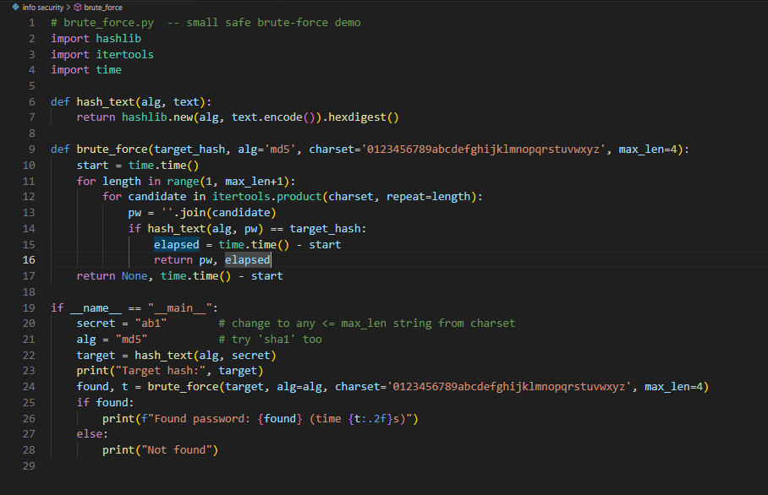

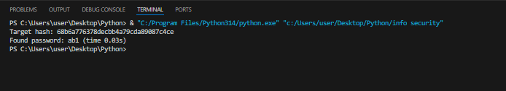

Secret = “ab1”, alg = sha1, max_length = 4

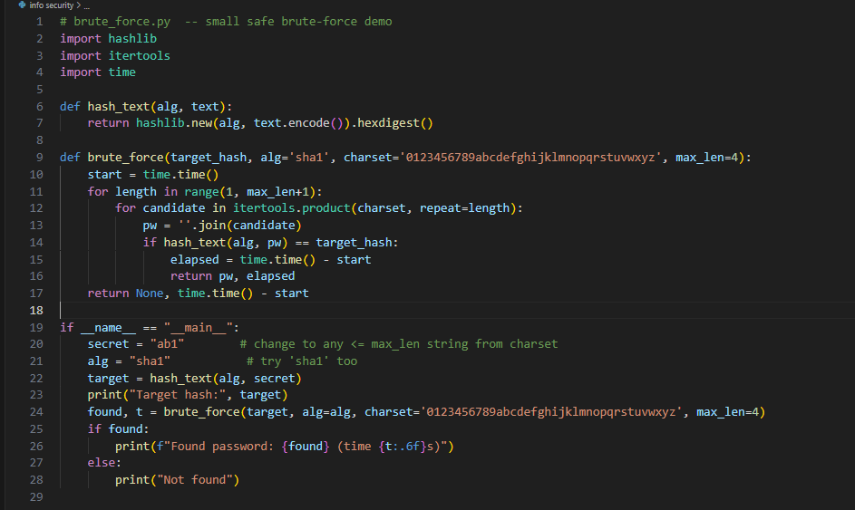

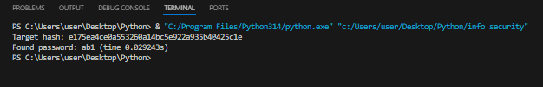

Secret = “ab”, alg = sha1, max_length = 3

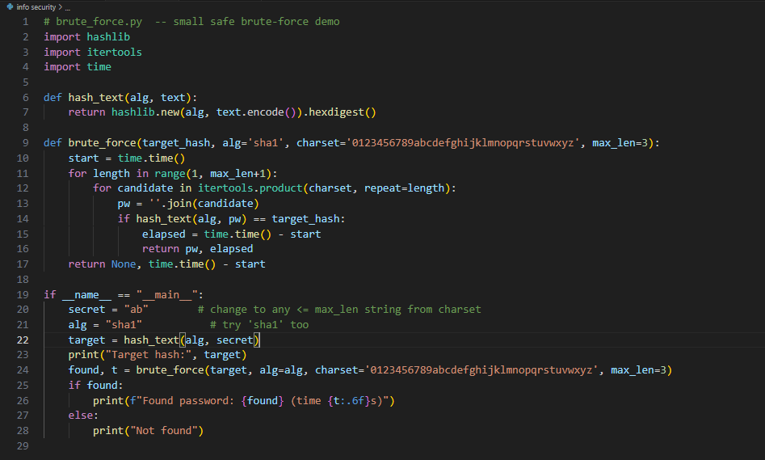

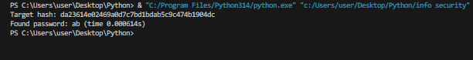

Secret = “ab”, alg = md5, max_length = 3

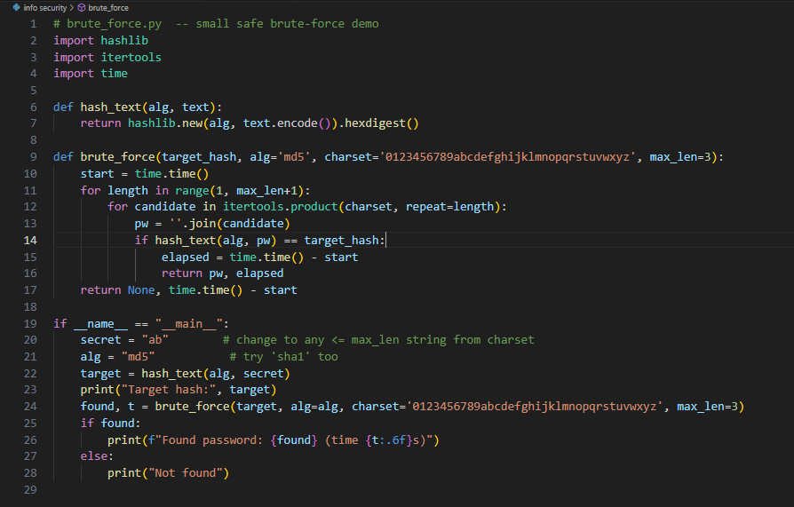

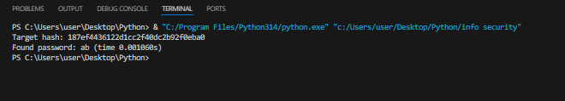

Secret = “a”, alg = md5, max_length = 2

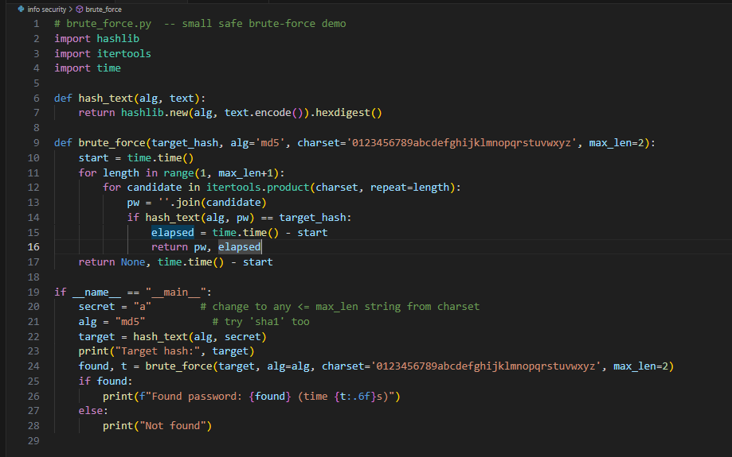

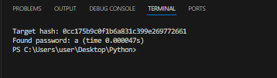

Secret = “a”, alg = sha1, max_length = 2

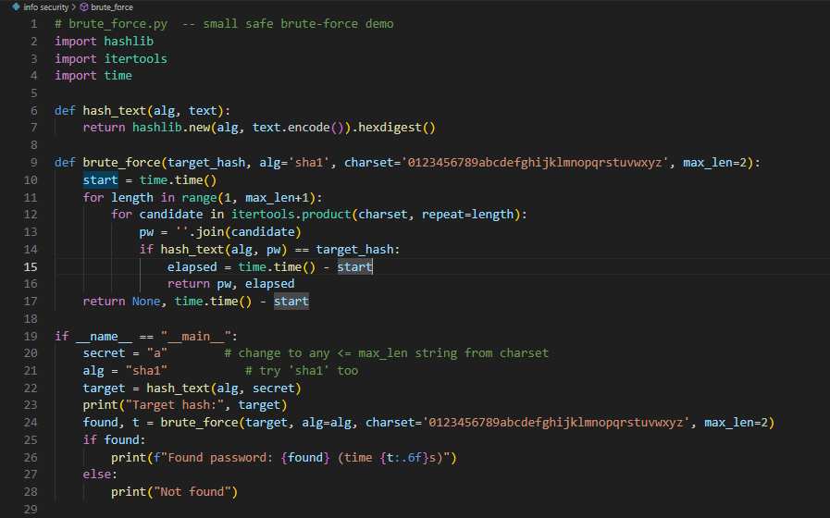
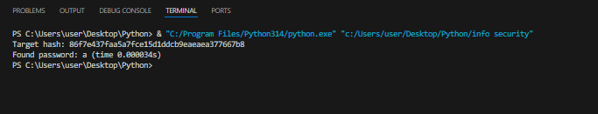
Reflection questions:
  - How long did it take to find "ab1"?
Ans: For the password "ab1":
- Using sha-1, it took 0.029243 seconds.
- Using md5, it took 0.03 seconds.
  - Estimate time to brute-force an 8-character password from the same charset.
Ans: Charset 0123456789abcdefghijklmnopqrstuvwxyz → total combos = 36^8=2,821,109,907,456.
• MD5: measured ~1,599,600 H/s → ~1,763,634 s ≈ 20.41 days.
• SHA-1: measured ~1,641,008 H/s → ~1,719,132 s ≈ 19.90 days.
Task B — Rainbow Table Generator & Lookup (Toy Example)
Goal: Generate a small rainbow table mapping passwords → hash chains, then use it to recover a hash quickly.
Note: This is a simplified educational version: a direct mapping plaintext → hash for a limited keyspace.
- Code (rainbow_demo.py):
# rainbow_demo.py -- toy rainbow table (direct map) for demo only import hashlib
import itertools import json import time
from pathlib import Path

def hash_text(alg, text):
return hashlib.new(alg, text.encode()).hexdigest()

def generate_table(path, alg='md5', charset='ab012', max_len=3): table = {}
start = time.time()
for length in range(1, max_len+1):
for candidate in itertools.product(charset, repeat=length): pw = ''.join(candidate)
table[hash_text(alg, pw)] = pw elapsed = time.time() - start Path(path).write_text(json.dumps(table))
print(f"Saved table to {path} (entries: {len(table)}, time
{elapsed:.2f}s)")

def lookup(path, target_hash):
table = json.loads(Path(path).read_text()) return table.get(target_hash)

if name == " main ": table_file = "rainbow_small.json" alg = "md5"
if not Path(table_file).exists():
generate_table(table_file, alg=alg, charset='ab012', max_len=3) # pick a secret
secret = "b1"
target = hash_text(alg, secret) print("Target hash:", target) found = lookup(table_file, target) if found:
print("Recovered from table:", found) else:
print("Not found in table")

What students do:
- Generate the small rainbow table (it will create a JSON file mapping hashes → plaintext).
- Use the lookup function to recover secrets.
- Observe speed: lookup is nearly instant compared to brute-force.

Original (MD5, charset ab012, max_len=3)
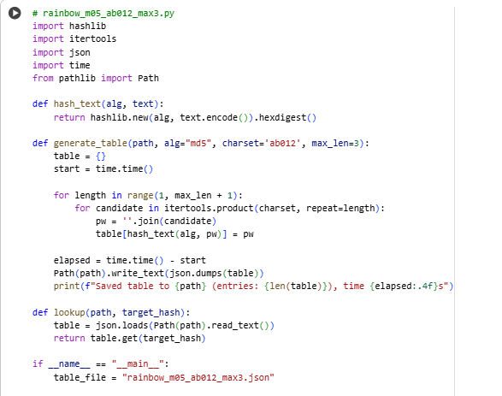
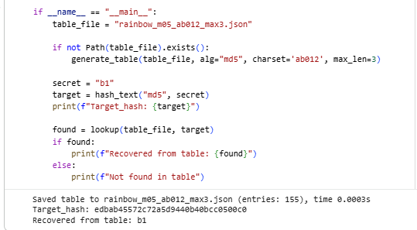

Experiment variations:
  - Increase max_len or charset and observe table file size & creation time.
Larger charset (md5, charset ab012345, max_len=3)
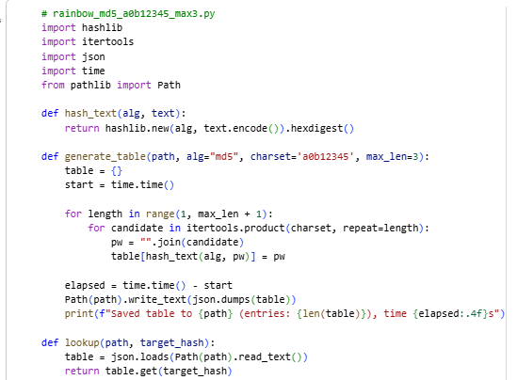
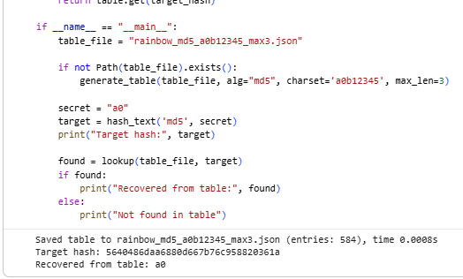

Increase max_len (md5, charset ab012, max_len=4)
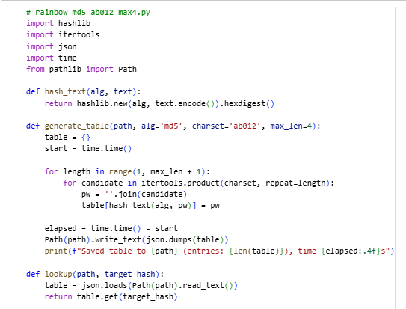
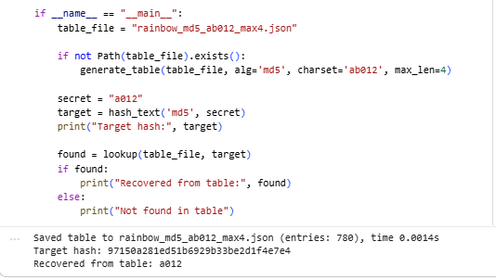

- Try alg="sha1" and compare sizes/time.
Same but SHA-1 (charset ab012, max_len=3)
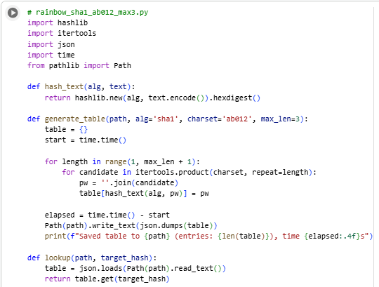
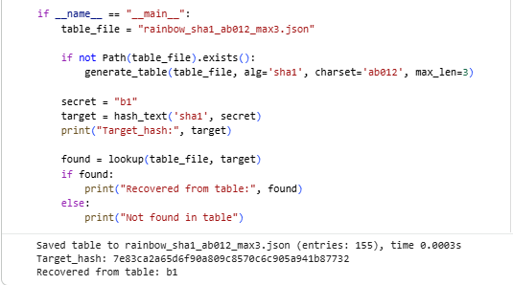
Reflection questions:
  - How much disk space did the table use?
Answer: The generated rainbow table file used approximately 6.47 KB of disk space for the configuration with charset = 'ab012' and max_len = 3, containing about 155 entries. When using the SHA-1 hash algorithm, the file size increased slightly to around 7 KB due to the longer hash values produced by SHA-1 compared to other hash functions.
- How did generation time change when you increased charset/length?
Answer: When charset or max_len increases, the table’s entries and creation time grow exponentially.
For example:
• Charset ab012 with max_len = 3 → ~0.0003 s.
• Charset ab012 with max_len = 3 → ~0.0003 s (using SHA-1).
• Increasing max_len = 4 with same charset ab012 → ~0.0014 s.
• Increasing charset ab012345 with max_len = 3 → ~0.0008 s.
• Increasing charset or max_len adds many more combinations and generation time increases sharply, though lookup still stays almost instant.

Task C — Salted Hash Failure of Rainbow Tables
Goal: Show that adding a salt prevents direct lookup in precomputed tables. Code snippet:
import hashlib

def salted_hash(alg, salt, password):
return hashlib.new(alg, (salt + password).encode()).hexdigest()

salt = "SALT!" password = "ab1" print("Salt:", salt)
print("Plain hash:", hashlib.md5(password.encode()).hexdigest()) print("Salted hash:", salted_hash('md5', salt, password))

Exercise:
  - Use the rainbow table from Task B to try to find the salted hash — it will fail because table contains hashes of unsalted passwords.
  - Discussion: To attack salted hashes, attacker would need to re-compute a rainbow table per salt (which is impractical at scale).
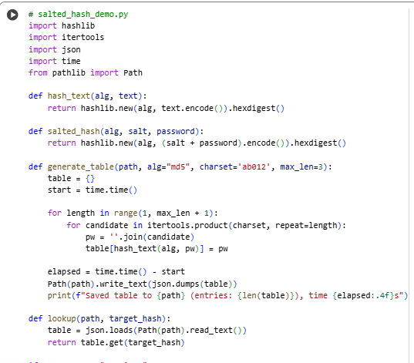
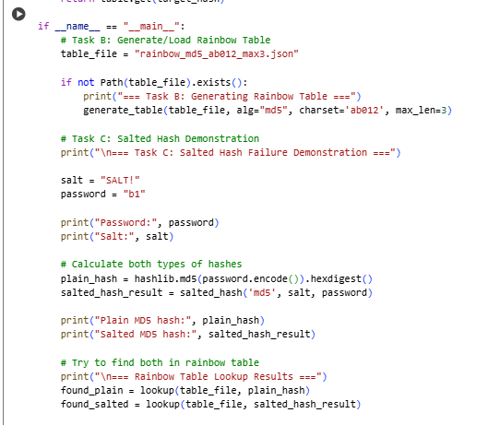
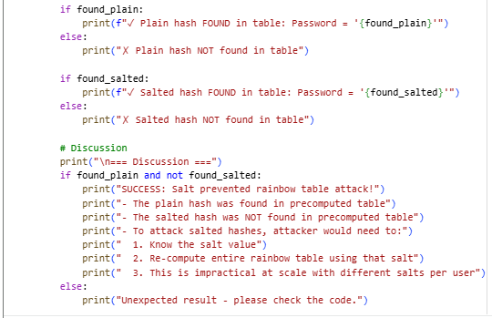
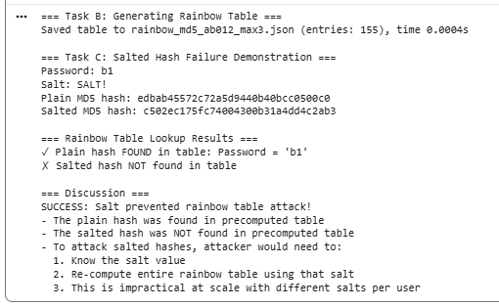

Task D — Compare and Report (Group/Individual)
Prepare a short report (1–2 pages) containing:
  - Screenshots of brute-force runs (Task A) and rainbow table generation/lookup (Task B).
Brute Force (Task 1):
Secret = “ab1”, alg = md5, max_length = 4

Secret = “ab”, alg = md5, max_length = 3

Secret = “a”, alg = md5, max_length = 2

Rainbow Table (Task B):

  - Table: charset, max_len, number of entries, table file size, generation time.

Algorithm | Charset | Max_len | No. of Entries | File Size | Generation time
MD5 | ab012 | 3 | 155 | 6.2 KB | 0.0003s
SHA-1 | ab012 | 3 | 155 | 7.4 KB | 0.0003s
MD5(larger charset) | ab012345 | 3 | 584 | 23.3 KB | 0.0008s
MD5(greater max_len) | ab012 | 4 | 780 | 31.8 KB | 0.0014s

- Explain: time vs space tradeoffs (brute-force slower, rainbow table faster lookup but uses storage).
Ans: Time vs Space Trade-off
Brute-force: minimal storage but slow, as each password must be hashed on-the-fly.
Rainbow table: very fast lookup but requires storage and precomputation.
Salting renders rainbow tables ineffective, since a separate table would be needed for each salt. Combining salts, slow hashers (bcrypt/Argon2), rate-limiting, and MFA provides the strongest defense.
- Show salt experiment and explain why salts are effective.
Ans: We added a salt "SALT!" to the password "ab1" and computed the hash as MD5(salt + password). Attempting to recover this salted hash using a rainbow table of unsalted hashes failed, because the table contains only MD5(password) entries.
Each password becomes unique per user, so precomputed tables can’t be reused, forcing attackers to brute-force individually — making attacks impractical.
  - Conclude with recommended defenses for real systems (salting, slow hashers, rate- limiting, MFA).
Ans: Conclusion — Recommended Defenses
To secure passwords, always use unique salts so that rainbow tables cannot be reused. Employ slow hash functions (e.g., bcrypt, Argon2) to make brute-force attacks costly. Implement rate-limiting to prevent rapid login attempts. Add multi-factor authentication (MFA) for an extra layer of protection. Together, these measures greatly reduce the risk of password compromise, even if hashes are exposed.

Submission Requirements (LMS)
File: YourName_RainbowBruteLab.docx or PDF. Contents:
  - Short introduction (purpose).
  - Screenshots of code output (Tasks A–C).

  - Table with measurements (size, time).
  - Answers to reflection questions.
  - Your conclusions and recommended defenses.
Optional: Attach the generated rainbow table JSON (if small) as evidence.

Marking Rubric
Component Description Marks

Code & Execution (Tasks A,B)
Experiments & Measurements
Salt demonstration & Analysis
Report clarity & screenshots
Scripts run correctly; outputs shown
Table size/time; correct observations
Show salted hash and explain effect
Screenshots included and readable

Conclusion & defenses Quality of recommendations

